CHRIS BROWNHILL T&D ’23
F2D REPORT

The F2D event for the Chris Brownhill T&D ’23 was flown as scheduled on Sunday June 4th. The forecasted strong winds that caused cancellation of the F2B of Saturday only partially materialized.
The event afforded entrants the chance to Win a very Limited-Edition certificate with Walter Dordolo’s F2D model watermarked in the background. The desire to Win such a fabulous keep-sake enticed 5 brave pilots to ante up their entry fee.
Brad LaPointe and Len Bourel journeyed up from Dresden to handle Circle Marshal and Scoring duties. Stunt Stu drifted in and volunteered to act as Head Judge. John McFayden motored in from Dundas with stakes and ropes to partition off the field and a camera to catch the action. Pat and Ivan Mackenzie laid out the center circle and field markings because they are the only ones that actually know the rules! Maksim brought his friend Igor as a judge trainee.
Once the pairings were drawn, Brad conducted a pilot’s meeting and the joust began.
Once all the streamers and bits of balsa had fluttered to the ground, undefeated Ivan Mackenzie was crowned 2023 Chris Brownhill T&D F2D Champion.
2nd place went to Maksim and Walter was very chuffed to earn the 3rd place certificate complete with the much sought after Dordolo watermark.
4th place was decided by the traditional coin toss which landed in favour of Vadim.

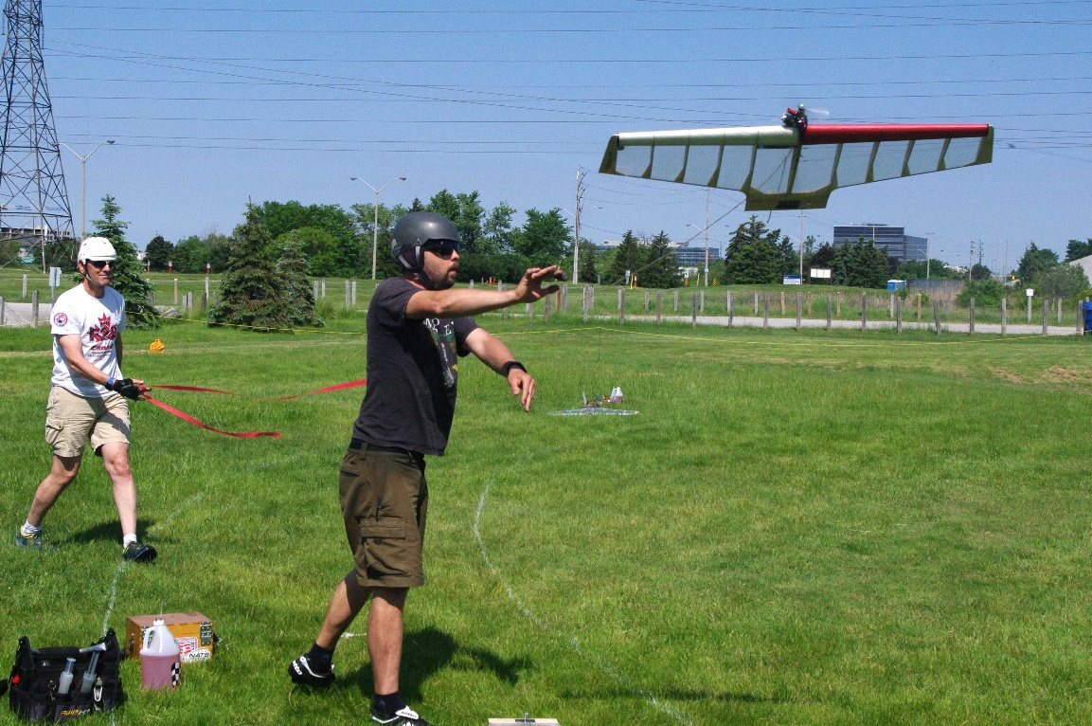
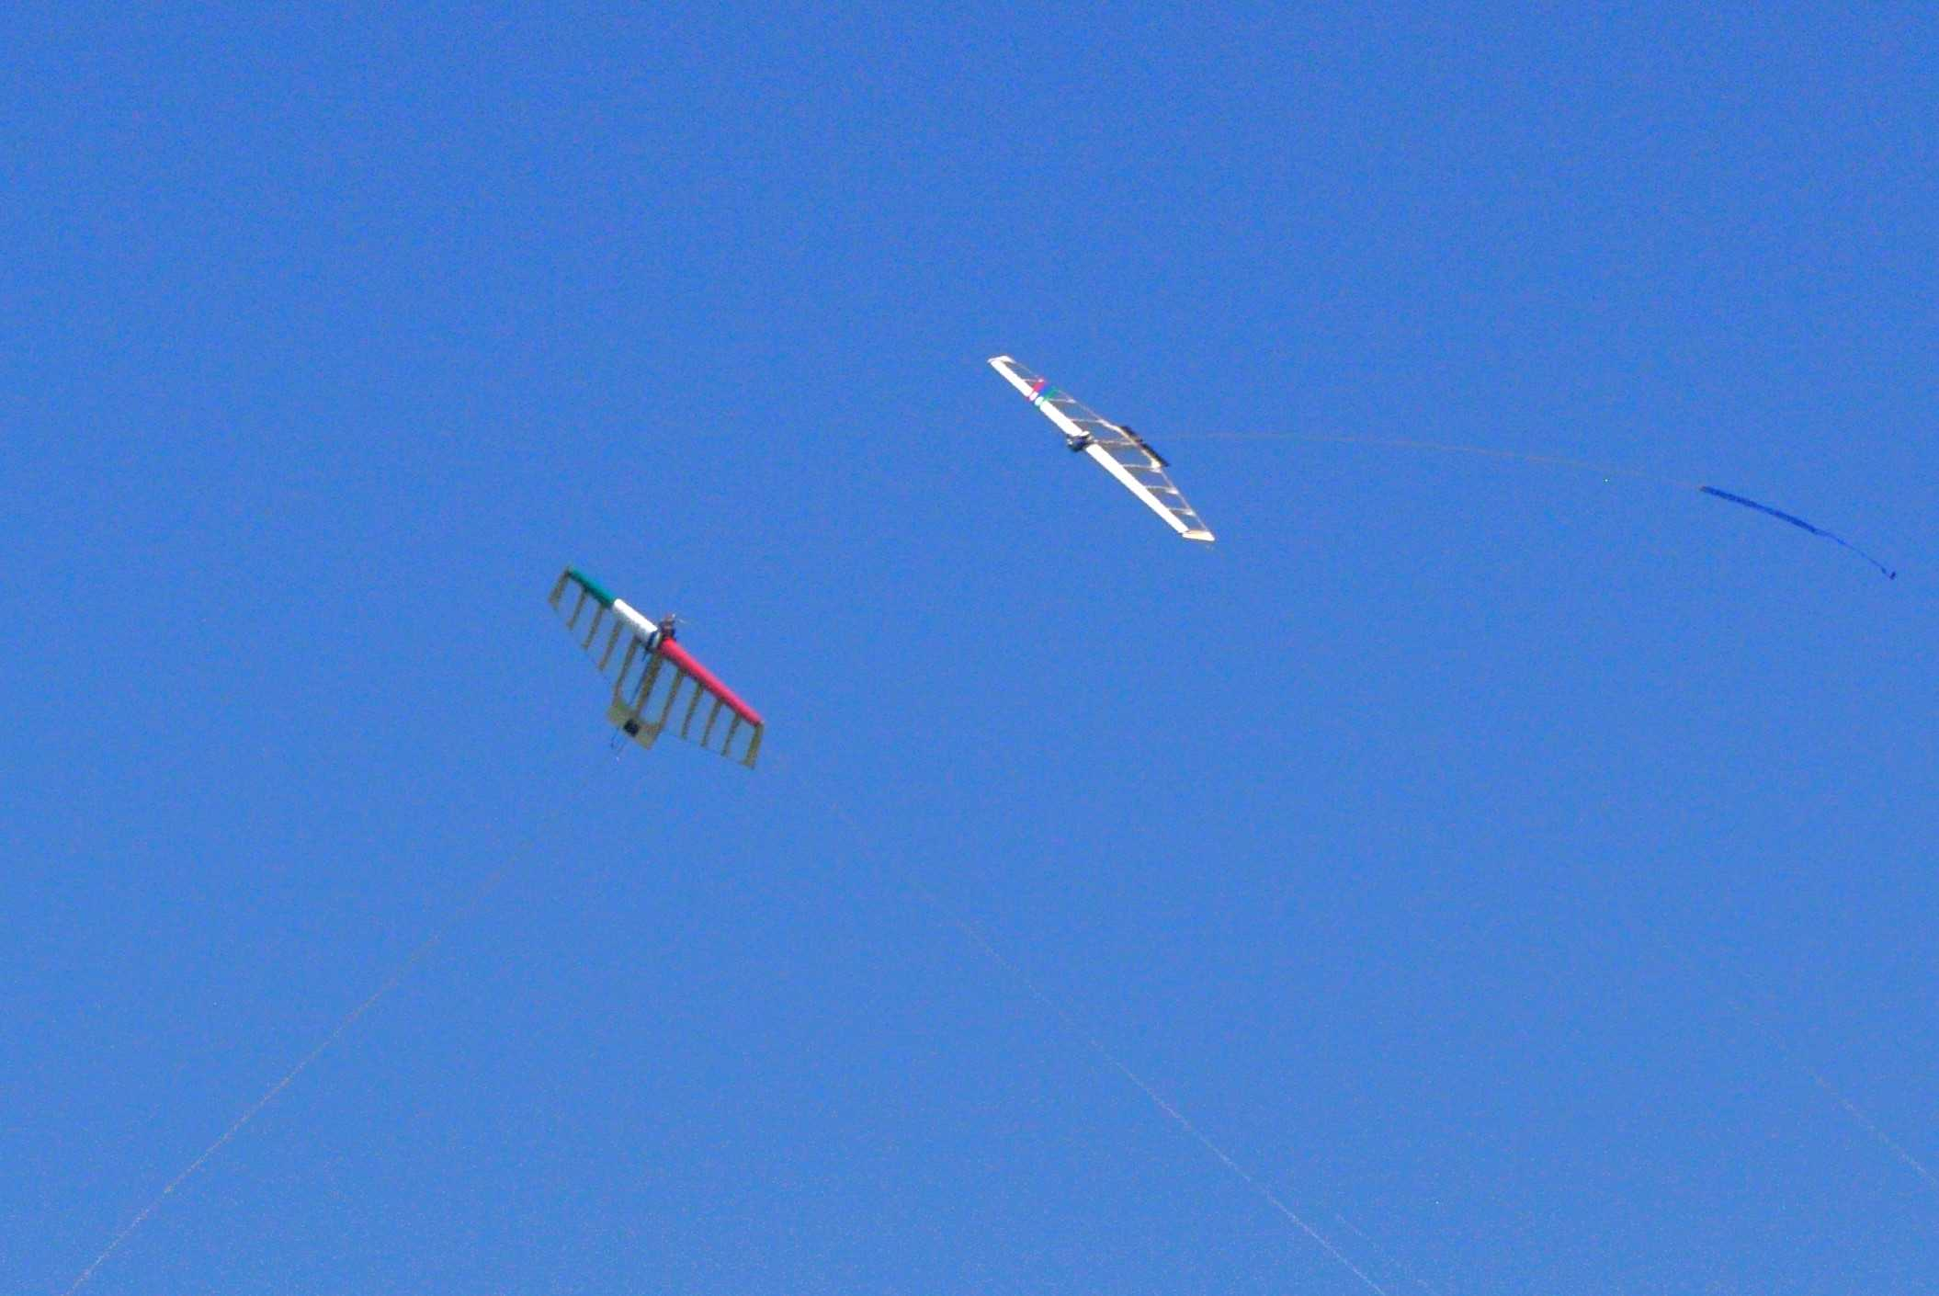
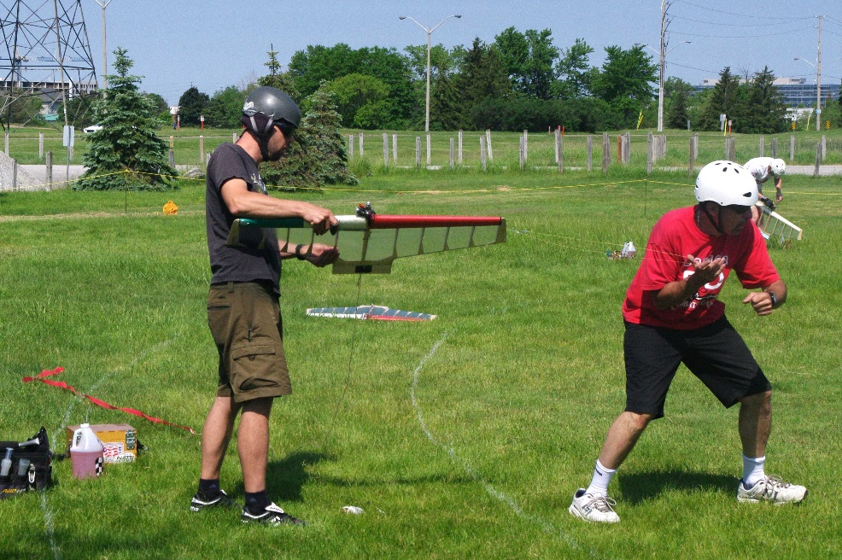
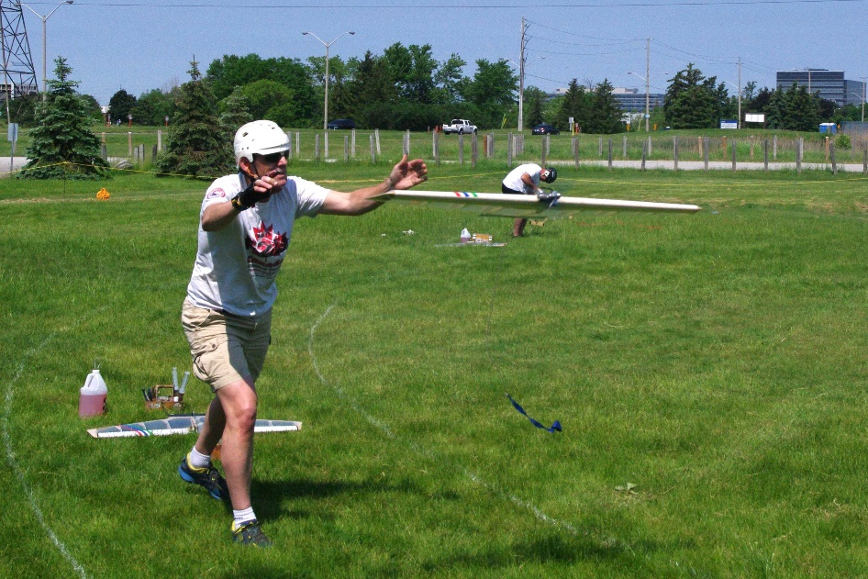
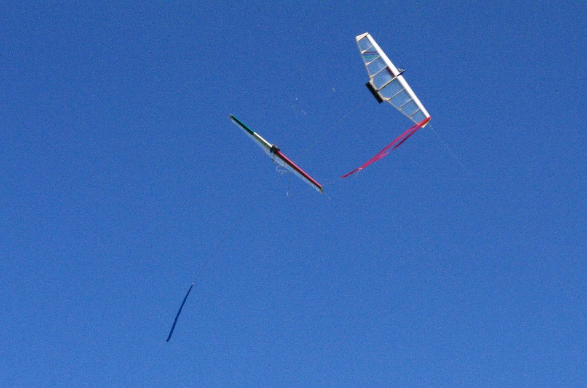
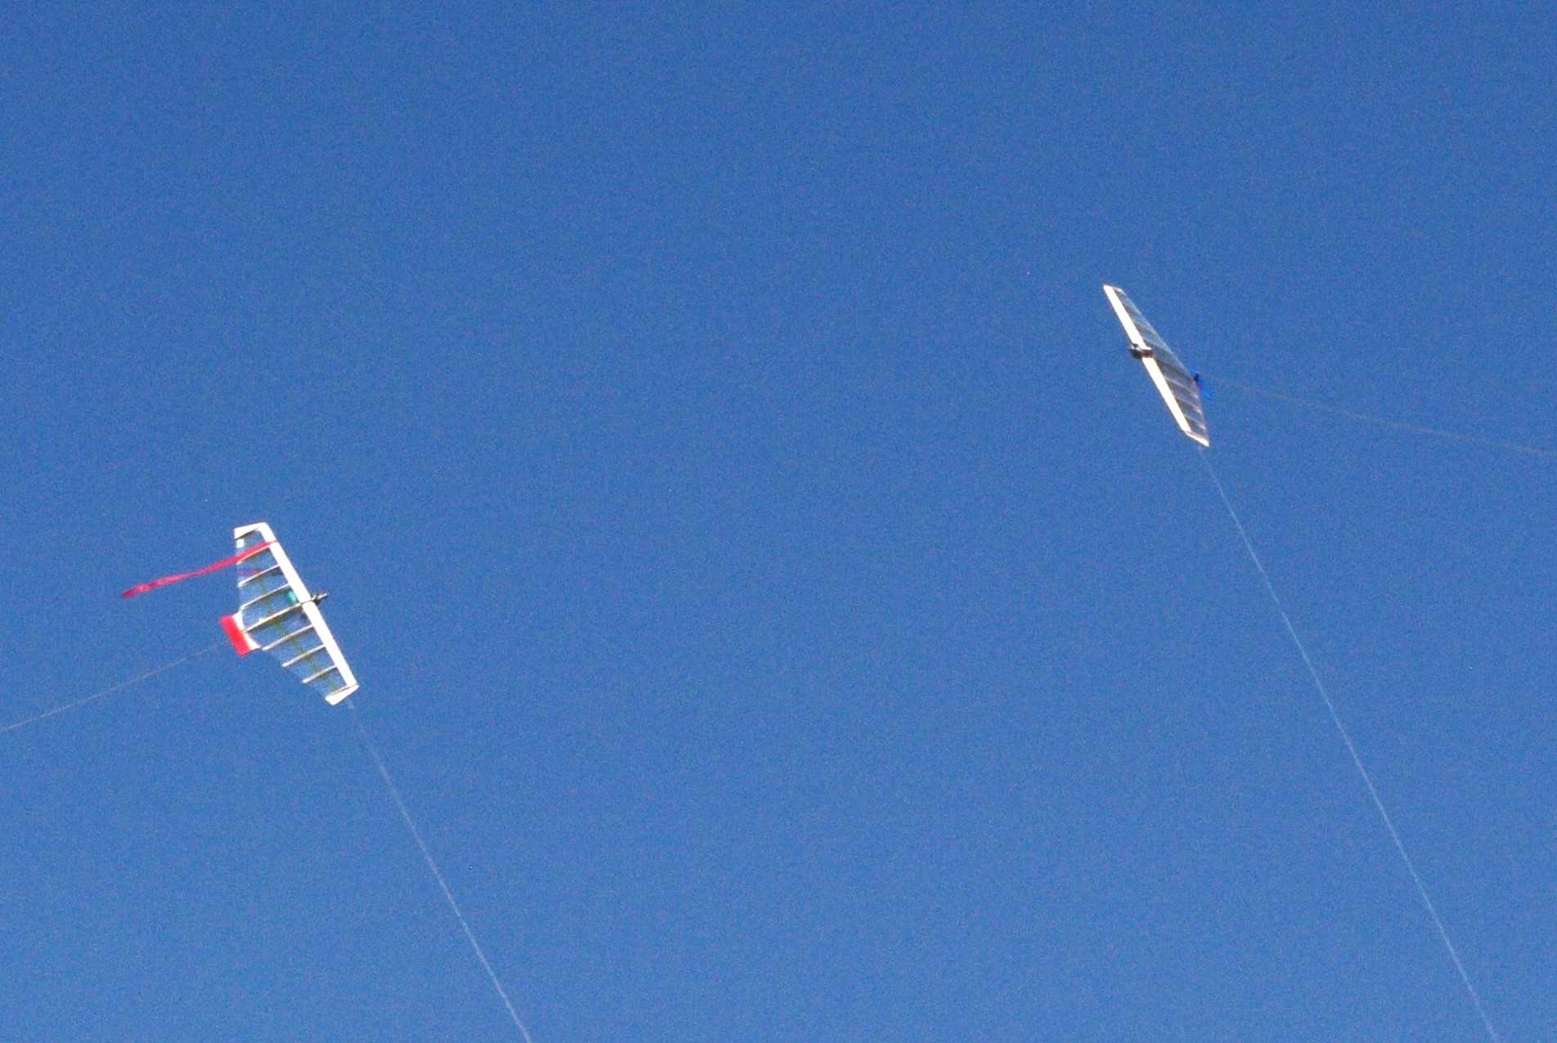
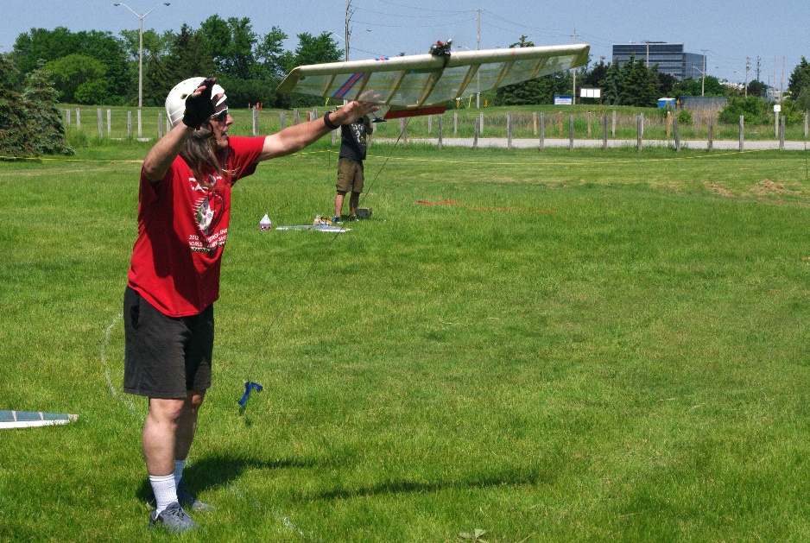
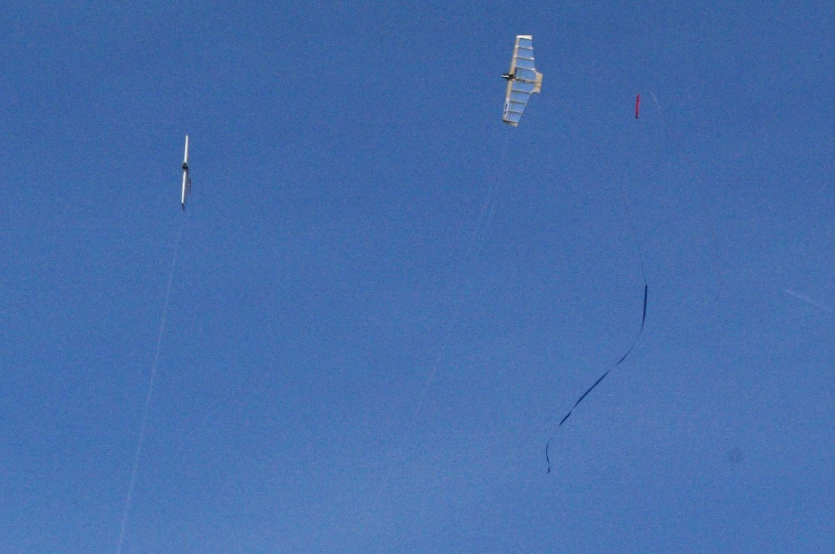
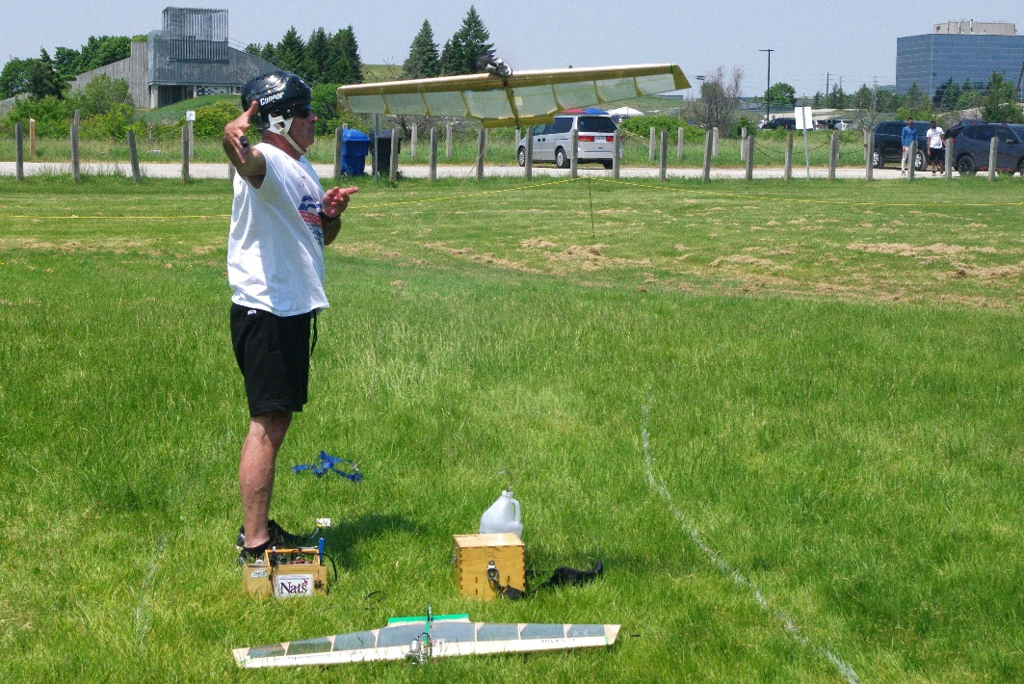
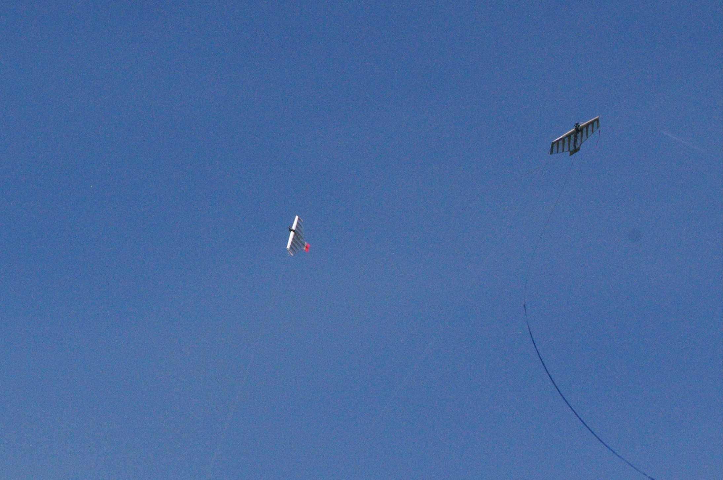
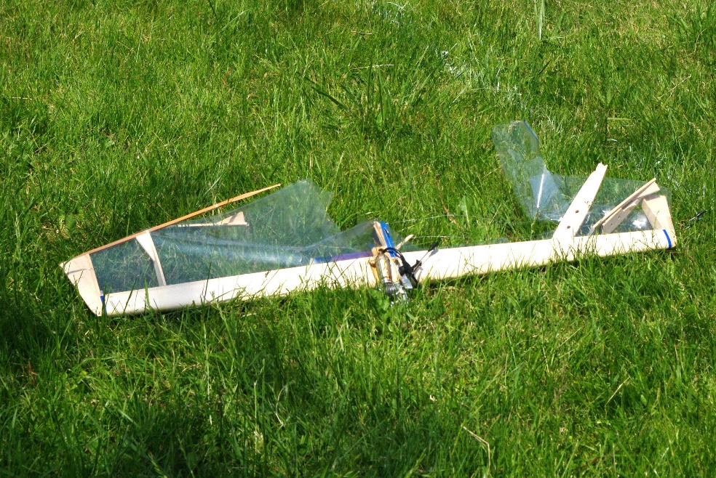
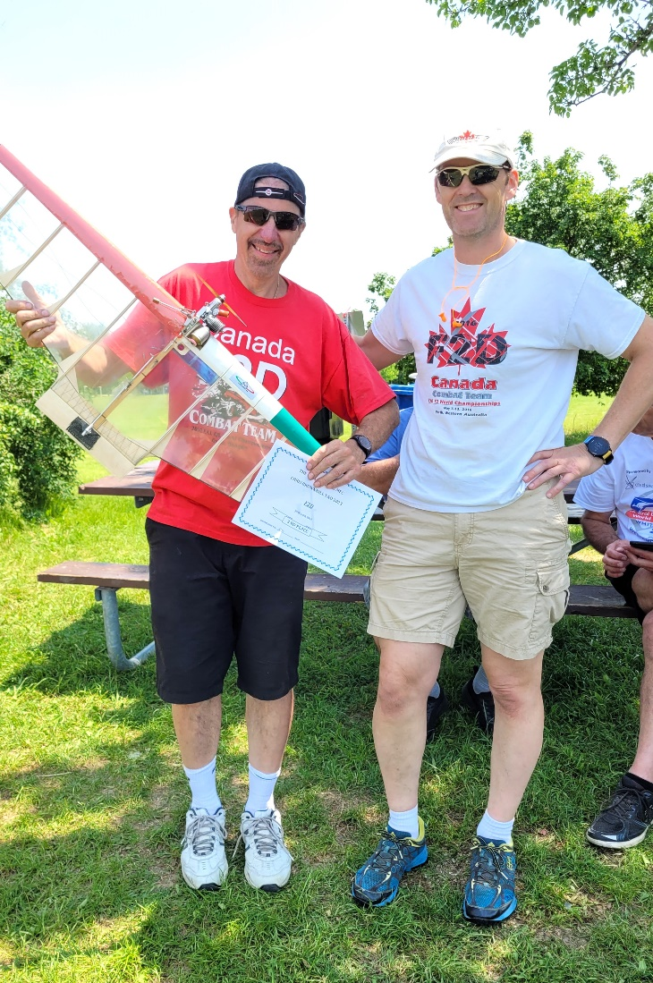
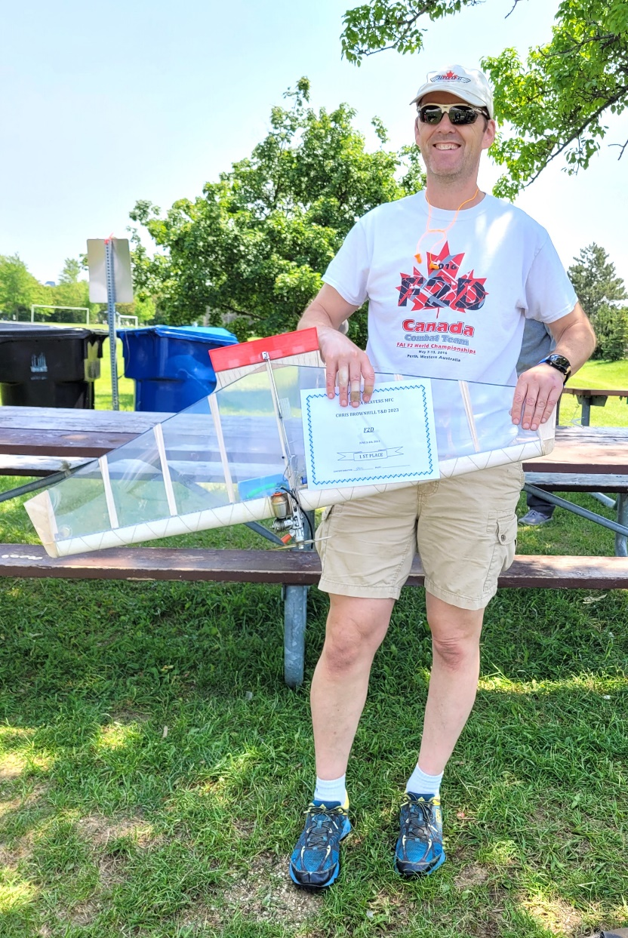
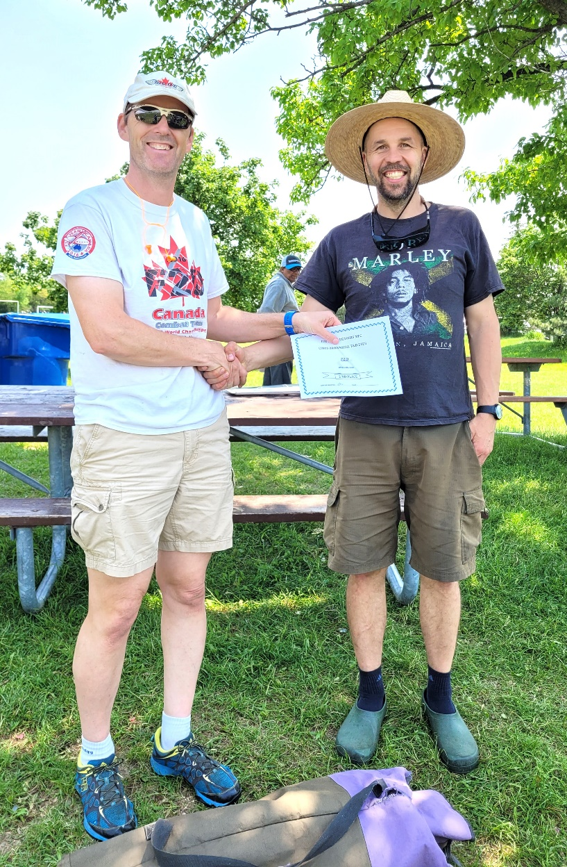
2023 T&D F2D CHAMPION

